



Spring Boot
/smlcodes /smlcodes /smlcodes

A SmlCodes.Com Small presentation
In Association with Idleposts.com


Spring Boot Tutorial

TUTORIAL

Small Codes
Programming Simplified

Copyright © 2016 SmlCodes.com All rights Reserved.

For more tutorials & Articles visit SmlCodes.com

Copyright © 2017 Smlcodes.com
All rights reserved. No part of this book may be reproduced, stored in a retrieval system, or transmitted in any form or by any means, without the prior written permission of the publisher, except in the case of brief quotations embedded in critical articles or reviews.
Every effort has been made in the preparation of this book to ensure the accuracy of the information presented. However, the information contained in this book is sold without warranty, either express or implied. Neither the author, SmlCodes.com, nor its dealers or distributors will be held liable for any damages caused or alleged to be caused directly or indirectly by this book.
Smlcodes.com has endeavored to provide trademark information about all the companies and products mentioned in this book by the appropriate use of capitals. However, SmlCodes.com Publishing cannot guarantee the accuracy of this information.
If you discover any errors on our website or in this tutorial, please notify us at support@smlcodes.com or smlcodes@gmail.com

First published on Sep 2017, Published by SmlCodes.com

Author Credits
Name : Satya Kaveti
Email : satyakaveti@gmail.com
Website : smlcodes.com
Digital Partners
  1
TUTORIAL 1
Spring Boot Tutorial 1
1. Introduction 4
Creating Spring Boot Application 5
2. Spring Boot Examples 7
1.Spring Boot with maven and Eclipse Example 7
2.Spring Boot with Spring Initializr Example 11
3. Spring Boot –Configurations 18
How to change Spring Boot Banner Text 18
application.properties 18
4. Spring Boot –MVC 20
Spring Boot MVC Example 20
Spring Boot –RESTful Web Service Example 24
5. Spring Boot –Database 26
Spring Boot –JDBC Example 26
Spring Boot –JPA Example 31
JpaRepository 34
Spring Boot –MongoDB REST Example 39
References 41

1. Introduction
Spring Boot makes it easy to create stand-alone, production-grade Spring based Applications that you can "just run".

Spring vs SpringBoot
Spring: Spring started as a lightweight alternative to Java Enterprise Edition (J2EE). Spring offered a simpler approach to enterprise Java development, utilizing dependency injection and aspect-oriented programming to achieve the capabilities of EJB with plain old Java objects (POJOs).
But while spring was lightweight in terms of component code, it was heavyweight in terms of configuration. Initially, spring was configured with XML & Spring 2.5 introduced annotation-based component-scanning, even so, there was no escape from configuration.

Spring boot: project is just a regular spring project that happens to leverage Spring Boot starters and auto-configuration. Spring Boot is not a framework, it is a way to ease to create stand-alone application with minimal or zero configurations.
Finally, Spring Boot is just spring. Spring projects would not have any XML configurations as part of it, everything will be handled by the project Spring Boot.
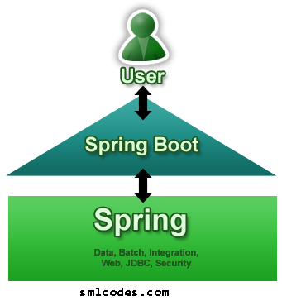
Spring Boot Features
- Create stand-alone Spring applications
- Embed Tomcat, Jetty or Undertow directly (no need to deploy WAR files)
- Provide opinionated 'starter' POMs to simplify your Maven configuration
- Automatically configure Spring whenever possible
- Provide production-ready features such as metrics, health checks and externalized configuration
- Absolutely no code generation and no requirement for XML configuration
We can develop two flavors of Spring-Based Applications using Spring Boot
- Java-Based Applications
- Groovy Application
Groovy is also JVM language almost similar to Java Language. We can combine both Groovy and Java into one Project. Because like Java files, Groovy files are finally compiled into *.class files only. Both *.groovy and *.java files are converted to *.class file (Same byte code format).
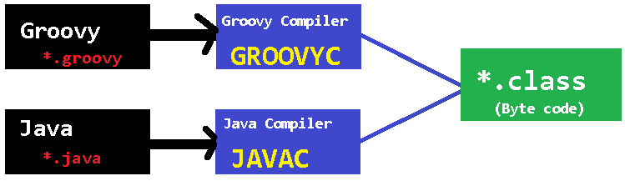
Spring Boot Framework Programming model is inspired by Groovy Programming model. Spring Boot internally uses some Groovy based techniques and tools to provide default imports and configuration.

Creating Spring Boot Application
To create Spring Boot based applications The Spring Team (The Pivotal Team) has provided the following three approaches.
- Using Maven
- Using Spring Initializer (http://start.spring.io/)
- Using Spring STS IDE
- Using Spring Boot CLI Tool

1. Spring Boot using Maven
Add maven dependencies in pom.xml & do maven build
<project>
<parent>
<groupId>org.springframework.boot</groupId>
<artifactId>spring-boot-starter-parent</artifactId>
<version>1.5.6.RELEASE</version>
</parent>

<dependencies>
<dependency>
<groupId>org.springframework.boot</groupId>
<artifactId>spring-boot-starter-web</artifactId>
</dependency>
</dependencies>

<properties>
<java.version>1.8</java.version>
</properties>

</project>

2.Spring Initializer
Spring Initializer provides an extensible API to generate quick start projects. It also provides a configurable service: you can see our default instance at https://start.spring.io. It provides a simple web UI to configure the project to generate and endpoints that you can use via plain HTTP.
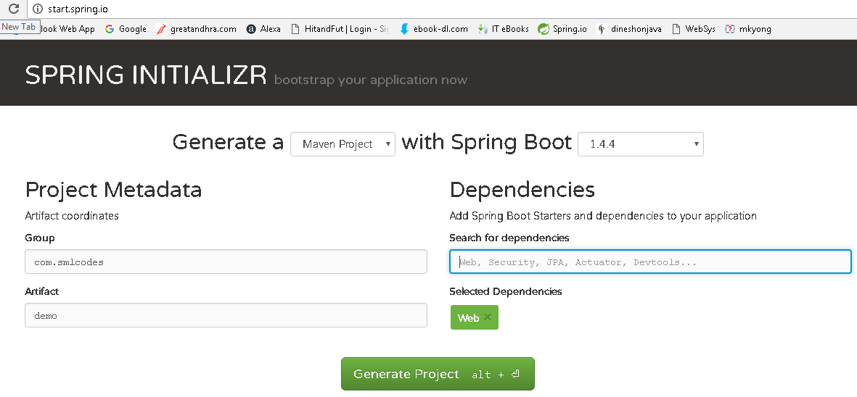
It will generate the Artifact.zip file, extract it and run maven build: mvn clean install package
[INFO] --- spring-boot-maven-plugin:1.4.4.RELEASE:repackage (default) @ SpringBootDemo ---
[INFO] ------------------------------------------------------------------------
[INFO] BUILD SUCCESS
[INFO] ------------------------------------------------------------------------
[INFO] Total time: 01:27 min
[INFO] Finished at: 2017-01-30T18:55:21+05:30
[INFO] Final Memory: 27M/160M
[INFO] ------------------------------------------------------------------------

3.Spring STS IDE
The Spring Tool Suite is an Eclipse-based development environment that is customized for developing spring applications. We can download it from here.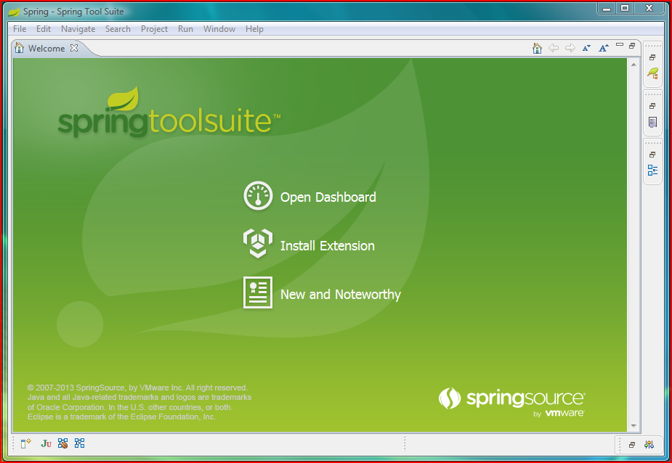

4.Spring Boot CLI Tool
The Spring Boot CLI is a command line tool that can be used if you want to quickly prototype (creates project Structure) with Spring. It allows you to run Groovy scripts, which means that you have a familiar Java-like syntax, without so much boilerplate code.
You don’t need to use the CLI to work with Spring Boot but it’s definitely the quickest way to get a spring application off the ground.
You can download the Spring CLI distribution from the Spring software repository:
- spring-boot-cli-1.5.0.RELEASE-bin.zip
- spring-boot-cli-1.5.0.RELEASE-bin.tar.gz
SDKMAN! (The Software Development Kit Manager) can be used for managing multiple versions of various binary SDKs, including Groovy and the Spring Boot CLI. Get SDKMAN! from sdkman.io and install Spring Boot with
$ sdk install springboot
$ spring --version
Spring Boot v1.5.0.RELEASE

A simple web application that you can use to test your installation. Create a file called app.groovy as
$ spring run app.groovy
It will take some time when you first run the application as dependencies are downloaded. Subsequent runs will be much quicker.

2. Spring Boot Examples

1.Spring Boot with maven and Eclipse Example
1. Open Eclipse > File > New > Maven Project
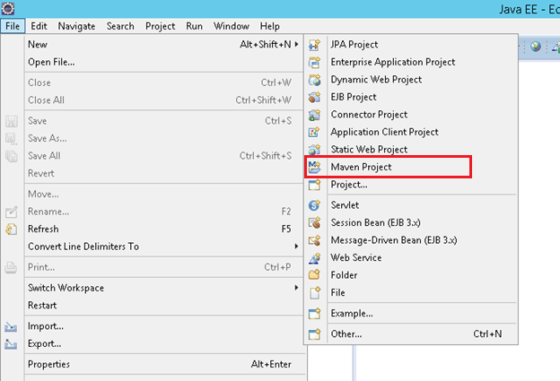
2.Tick ‘Create a simple project (skip archetype selection) ‘ check box > click Next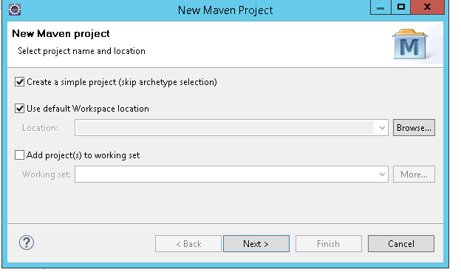
3. Provide Group Id (its your package), Artifact Id (project name) and click Finish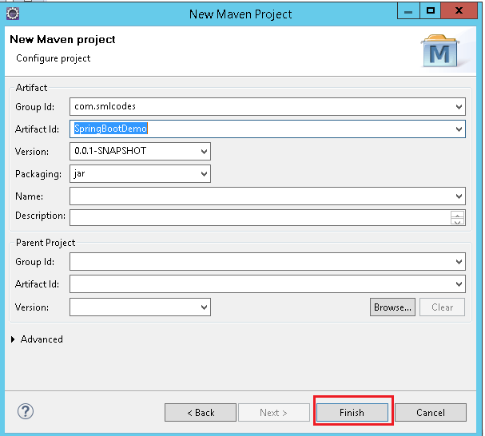
4. open pom.xml, add Spring Boot dependencies
<project>
<modelVersion>4.0.0</modelVersion>
<groupId>com.smlcodes</groupId>
<artifactId>SpringBootDemo</artifactId>
<version>0.0.1-SNAPSHOT</version>
<parent>
<groupId>org.springframework.boot</groupId>
<artifactId>spring-boot-starter-parent</artifactId>
<version>1.5.6.RELEASE</version>
</parent>

<dependencies>
<dependency>
<groupId>org.springframework.boot</groupId>
<artifactId>spring-boot-starter-web</artifactId>
</dependency>
</dependencies>

<properties>
<java.version>1.8</java.version>
</properties>
</project>
- spring-boot-starter-parent: is an existing project given by spring team which contains Spring Boot supporting configuration data (just configuration data, it won’t download any jars), we have added this in a <parent> tag means, we are instructing Maven to consider our SpringBootHelloWorld project as a child to it

- spring-boot-starter-web: Starter for building web, including RESTful, applications using Spring MVC. Uses Tomcat as the default embedded container

5.Now right click on the application > Maven > Update Project,
if you observe the directory structure of the project, it will create a new folder named “Maven Dependencies” which contains all supporting. jars to run the Spring Boot application and the Java version also changed to 1.8.
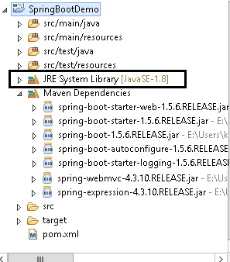
- if you observe pom.xml, we haven’t included version number for spring-boot-starter-web but maven downloaded some jar files with some version(s) related to spring-boot-starter-web, that’s because of Maven’s parent child relation.
- While adding spring boot parent project, we included version as 1.5.6.RELEASE, so again we no need to add version numbers for the dependencies. As we know spring-boot-starter-parent contains configuration meta data, this means, it knows which version of dependency need to be downloaded. So we no need to worry about dependencies versions., it will save lot of our time.

6.create a java class with main() method, in a pakage.com.smlcodes.app.SpringBootApp.java.
package com.smlcodes.app;

import org.springframework.boot.SpringApplication;
import org.springframework.boot.autoconfigure.SpringBootApplication;

@SpringBootApplication
public class SpringBootApp {
public static void main(String[] args) {
SpringApplication.run(SpringBootApp.class, args);
System.out.println("****\n Hello, World \n ***");
}
}
- @SpringBootApplication annotation, is the starting point for our Spring Boot application
- SpringApplication.run(SpringBootApp.class, args); it will bootstrapping the application
remember, for every spring boot application we have to create a main class and that need to be annotate with @SpringBootApplication and bootstrap it

8.Finally, right click on the application > Run As > Java Application
. ____ _ __ _ _
/\\ / ___'_ __ _ _(_)_ __ __ _ \ \ \ \
( ( )\___ | '_ | '_| | '_ \/ _` | \ \ \ \
\\/ ___)| |_)| | | | | || (_| | ) ) ) )
' |____| .__|_| |_|_| |_\__, | / / / /
=========|_|==============|___/=/_/_/_/
:: Spring Boot :: (v1.5.6.RELEASE)

2017-09-11 16:04:04.006 INFO 6724 --- [ main] com.smlcodes.app.SpringBootApp : Starting SpringBootApp on HYDPCMCSTS with PID 6724
2017-09-11 16:04:13.444 INFO 6724 --- [ main] com.smlcodes.app.SpringBootApp : Started SpringBootApp in 10.738 seconds (JVM running for 12.252)
************
Hello, World
*****************

2.Spring Boot with Spring Initializr Example
we are using Spring Initializer(https://start.spring.io) to create a template for spring boot application
1. Go to https://start.spring.io , Choose Dependencies & Generate Project. Here we are not selecting any dependencies because it is just a Hello world program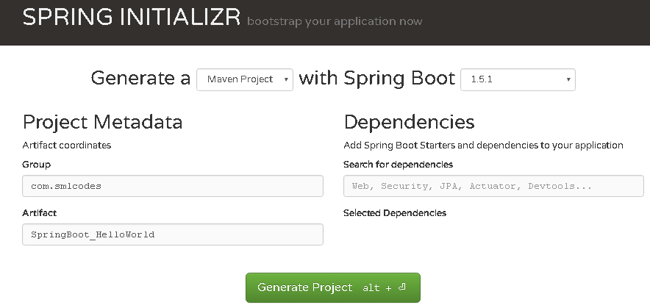

2. Open Eclipse, import→ Maven →Existing Maven Projects → Select Project →Finish
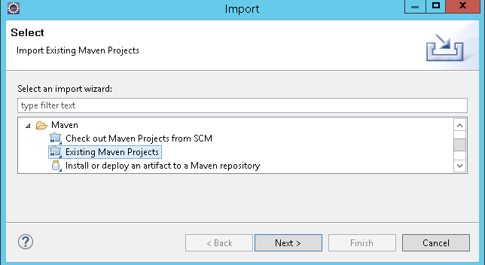

3. The Project structure will be as follows if we open eclipse Package explorer
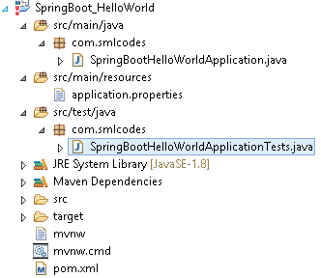
4. If we open the pom.xml it contains only basic dependencies like spring-boot-starter which allows start spring boot application
<dependencies>
<dependency>
<groupId>org.springframework.boot</groupId>
<artifactId>spring-boot-starter</artifactId>
</dependency>
<dependency>
<groupId>org.springframework.boot</groupId>
<artifactId>spring-boot-starter-test</artifactId>
<scope>test</scope>
</dependency>
</dependencies>

5. Select Project, Right click Run as→ maven install to download and install the dependencies. 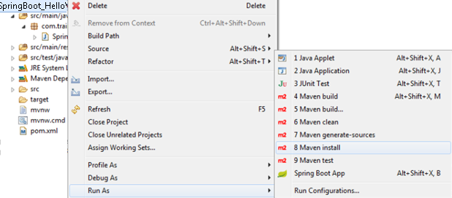

6.Spring boot generates the default java class which contains main() method. The main method calls the run method of SpringApplication. SpringApplication.run(SpringBootHelloWorldApplication.class, args); This run method bootstraps the application starting spring which will run the embedded Tomcat Server. Let’s add some helloworld message to print
package com.smlcodes;
import org.springframework.boot.SpringApplication;
import org.springframework.boot.autoconfigure.SpringBootApplication;

@SpringBootApplication
public class SpringBootHelloWorldApplication {
public static void main(String[] args) {
SpringApplication.run(SpringBootHelloWorldApplication.class, args);
System.out.println("============================================");
System.out.println("Hello World, Spring Boot!!!!");
System.out.println("=============www.smlcodes.com===============");
}
}
7. Select the Java file and right click RunAs → Java Application
/\\ / ___'_ __ _ _(_)_ __ __ _ \ \ \ \
( ( )\___ | '_ | '_| | '_ \/ _` | \ \ \ \
\\/ ___)| |_)| | | | | || (_| | ) ) ) )
' |____| .__|_| |_|_| |_\__, | / / / /
=========|_|==============|___/=/_/_/_/
:: Spring Boot :: (v1.5.1.RELEASE)
2017-01-31 11:05:32.745 INFO 29596 --- [ main] s.c.a.AnnotationConfigApplicationContext : Refreshing org.springframework.context.annotation.AnnotationConfigApplicationContext@646007f4: startup date [Tue Jan 31 11:05:32 IST 2017]; root of context hierarchy
2017-01-31 11:05:43.108 INFO 29596 --- [ main] o.s.j.e.a.AnnotationMBeanExporter : Registering beans for JMX exposure on startup
2017-01-31 11:05:43.200 INFO 29596 --- [ main] c.s.SpringBootHelloWorldApplication : Started SpringBootHelloWorldApplication in 12.855 seconds (JVM running for 16.094)
============================================
Hello World, Spring Boot!!!!
=============www.smlcodes.com===============

8. We can also run this application from the command line using the jar file that is generated. To get the jar file, select pom.xml right click RunAs → Maven Build (2nd one), goals=package, Apply & Run 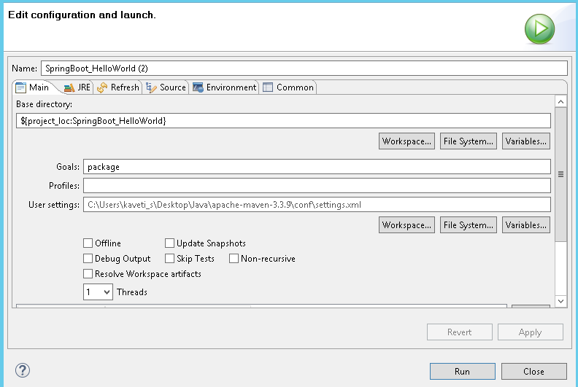
[INFO] Scanning for projects
[INFO] --------------------------------------------------------------------
[INFO] Building SpringBoot_HelloWorld 0.0.1-SNAPSHOT
[INFO] ----------------------------------------------------------------------
C:\Users\kaveti_s\Desktop\Downloads\SpringBoot_HelloWorld\SpringBoot_HelloWorld\target\SpringBoot_HelloWorld-0.0.1-SNAPSHOT.jar
[INFO] --- spring-boot-maven-plugin:1.5.1.RELEASE:repackage (default) @ SpringBoot_HelloWorld
[INFO] -------------------------------------------------------------------
[INFO] BUILD SUCCESS
[INFO] -------------------------------------------------------------------

9. Open command line and go to the folder where your project is located. Next, move to the target folder and then type java -jar <<filename>>.jar.
java -jar SpringBoot_HelloWorld-0.0.1-SNAPSHOT.jar
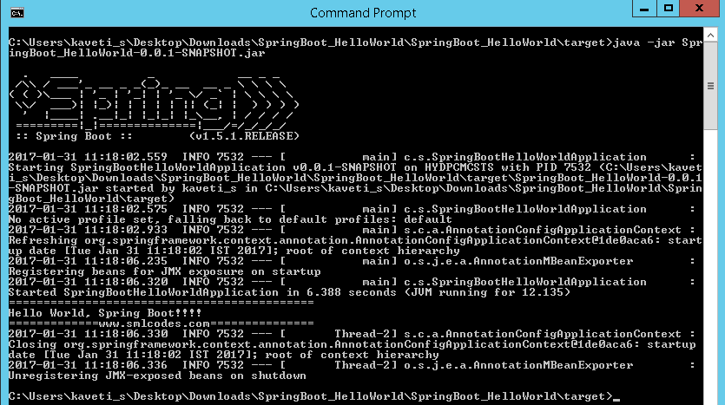

How it works internally
1. we place the all the required Spring boot starters in pom.xml which are requires for implementing Spring Boot application. on loading project, the all required starter dependencies are added automatically to the project
2. By running Spring Boot main class, at @SpringBootApplication line it will do the Auto configuration things, it will automatically add all required annotations to Java Class ByteCode.
3.On Executing main() method SpringApplication.run() used to bootstrap and launches Spring Boot application.

1.Spring Boot Starters
Spring boot Starters are the one-stop-shop for all the Spring and related technology that we need. For example, if you want to get started using Spring and JPA for database access, just include the spring-boot-starter-data-jpa dependency in your project, and you are good to go.
All official starters follow a similar naming pattern; spring-boot-starter-*, where * is a particular type of application. The following are the some of the application starters are provided by Spring Boot under the org.springframework.boot group
Name | Description
spring-boot-starter-web-services | Starter for using Spring Web Services
spring-boot-starter-web | Starter for building web, including RESTful, applications using Spring MVC. Uses Tomcat as the default embedded container
spring-boot-starter-test | Starter for testing Spring Boot applications with libraries including JUnit, Hamcrest and Mockito
spring-boot-starter-jdbc | Starter for using JDBC with the Tomcat JDBC connection pool
spring-boot-starter-jersey | Starter for building RESTful web applications using JAX-RS and Jersey. An alternative to spring-boot-starter-web
spring-boot-starter-aop | Aspect-oriented programming with Spring AOP and AspectJ
spring-boot-starter-security | Starter for using Spring Security
spring-boot-starter-data-jpa | Starter for using Spring Data JPA with Hibernate
spring-boot-starter | Core starter, including auto-configuration support, logging,YML

In above Example we used spring-boot-starter & spring-boot-starter-test Starters which are configure in pom.xml
<dependencies>
<dependency>
<groupId>org.springframework.boot</groupId>
<artifactId>spring-boot-starter</artifactId>
</dependency>
<dependency>
<groupId>org.springframework.boot</groupId>
<artifactId>spring-boot-starter-test</artifactId>
<scope>test</scope>
</dependency>
</dependencies>

2.@SpringBootApplication Annotation
This annotation marks the class as a spring bean, configures the application by adding all the jars based on the dependencies and also scans the other packages for spring beans.
Spring Boot developers always have their main class annotated with @Configuration, @EnableAutoConfiguration and @ComponentScan.
- @Configuration – Specifies this class as a spring bean
- @EnableAutoConfiguration – This tells how you want to configure Spring, based on the jar dependencies that you have added. & also Enable / Disable auto configuration
- @ComponentScan – is to scan other packages for spring beans.
- @Import - used to import additional configuration classes
- @ImportResource -annotation to load XML configuration files
import org.springframework.boot.SpringApplication;
import org.springframework.boot.autoconfigure.EnableAutoConfiguration;
import org.springframework.context.annotation.ComponentScan;
import org.springframework.context.annotation.Configuration;

@Configuration
@EnableAutoConfiguration
@ComponentScan
public class Application {
public static void main(String[] args) {
SpringApplication.run(Application.class, args);
}
}
Since these annotations are so frequently used together Spring Boot provides a convenient @SpringBootApplication as an alternative. The @SpringBootApplication annotation is equivalent to using @Configuration, @EnableAutoConfiguration and @ComponentScan with their default attributes.
@SpringBootApplication = @Configuration + @ComponentScan + @EnableAutoConfiration.
The original @SpringBootApplication annotation class is defined as below
package org.springframework.boot.autoconfigure; @Target(ElementType.TYPE)
@Retention(RetentionPolicy.RUNTIME)
@Documented
@Inherited
@Configuration
@EnableAutoConfiguration
@ComponentScan
public @interface SpringBootApplication {
Class<?>[] exclude() default {};

String[] excludeName()default{};

@AliasFor(annotation = ComponentScan.class, attribute = "basePackages")
String[] scanBasePackages() default {};

@AliasFor(annotation = ComponentScan.class, attribute = "basePackageClasses")
Class<?>[] scanBasePackageClasses()default{};
}

3 SpringApplication Class
SpringApplication class is used to bootstrap and launch a Spring application from a Java main method. By default, class will perform the following steps to bootstrap your application:
- Create an appropriate ApplicationContext instance (depending on your classpath)
- Register a CommandLinePropertySource to expose command line arguments as Spring properties
- Refresh the application context, loading all singleton beans
- Trigger any CommandLineRunner beans
In most circumstances the static run(Object, String[]) method can be called directly from your main method to bootstrap your application:
public static void main(String[] args) {
SpringApplication.run(MySpringConfiguration.class, args);
}

4. Embaded Servlet containers
The following embedded servlet containers are supported out of the box.By default we will get Tomcat
Name | Servlet Version | Java Version
Tomcat 8 | 3.1 | Java 7+
Tomcat 7 | 3.0 | Java 6+
Jetty 9.3 | 3.1 | Java 8+
Jetty 9.2 | 3.1 | Java 7+
Jetty 8 | 3.0 | Java 6+
Undertow 1.3 | 3.1 | Java 7+

5.Spring Boot Profiles (@Profile Annotation)
Spring Profiles provide a way to segregate parts of your application configuration and make it only available in certain environments. Any @Component or @Configuration can be marked with @Profile to limit when it is loaded
@Configuration
@Profile("production")
public class ProductionConfiguration {

// ...

}
In the normal Spring way, you can use a spring.profiles.active Environment property to specify which profiles are active. You can specify the property in any of the usual ways, for example you could include it in your application.properties:spring.profiles.active=dev,hsqldb or specify on the command line using the switch --spring.profiles.active=dev,hsqldb.

6. Spring Boot Actuator
Spring Boot provides actuator to monitor and manage our application. Actuator is a tool which has HTTP endpoints. when application is pushed to production, you can choose to manage and monitor your application using HTTP endpoints.
To get production-ready features, we should use spring-boot-actuator module. We can enable this feature by adding it to the pom.xml file.
<dependencies>
<dependency>
<groupId>org.springframework.boot</groupId>
<artifactId>spring-boot-starter-actuator</artifactId>
</dependency>
</dependencies>

3. Spring Boot –Configurations

How to change Spring Boot Banner Text
The banner that is printed on startup can be changed by adding a banner.txt file to src\main\resources folder or your classpath, or by setting banner.location to the location of such a file.
You can also add a banner.gif, banner.jpg or banner.png image file to your classpath, or set a banner.image.location property. Images will be converted into an ASCII art representation and printed above any text banner.
//Default Banner
. ____ _ __ _ _
/\\ / ___'_ __ _ _(_)_ __ __ _ \ \ \ \
( ( )\___ | '_ | '_| | '_ \/ _` | \ \ \ \
\\/ ___)| |_)| | | | | || (_| | ) ) ) )
' |____| .__|_| |_|_| |_\__, | / / / /
=========|_|==============|___/=/_/_/_/
:: Spring Boot :: (v1.5.1.RELEASE)
2017-02-01 14:07:22.957 INFO 72716 --- [ main] c.s.SpringBootHelloWorldApplication

- Go to any ANCII Text generator website & generate your logo. for ex: http://patorjk.com/
- Create banner.txt under Proj_Home\src\main\resources, paste the logo text
- Refresh the project & run Spring Boot Application.the banner will change as below
██████╗███╗ ███╗██╗ ██████╗ ██████╗ ██████╗ ███████╗███████╗
██╔════╝████╗ ████║██║ ██╔════╝██╔═══██╗██╔══██╗██╔════╝██╔════╝
███████╗██╔████╔██║██║ ██║ ██║ ██║██║ ██║█████╗ ███████╗
╚════██║██║╚██╔╝██║██║ ██║ ██║ ██║██║ ██║██╔══╝ ╚════██║
███████║██║ ╚═╝ ██║███████╗╚██████╗╚██████╔╝██████╔╝███████╗███████║
╚══════╝╚═╝ ╚═╝╚══════╝ ╚═════╝ ╚═════╝ ╚═════╝ ╚══════╝╚══════╝
2017-02-01 14:07:22.957 INFO 72716 --- [ main] c.s.SpringBootHelloWorldApplication

application.properties
Spring Boot provides a very neat way to load properties for an application. we can define properties in application.properties (PROJ_HOME\src\main\resources\application.properties) file the following way
db.name=smlcodesdb
db.username=smlcodes
db.password=wEB20R1XPJtg9

In traditional Spring application would have loaded up the properties in the following way
public class SmlcodesPropTest {
@Value("${db.name}") //dbname is KEY here
private String dbname;

@Value("${db. username }")
private String server_port;
In Spring boot it takes application.properties file to define a bean that can hold all the related properties in following way
@ConfigurationProperties(prefix = "db")
@Component
public class DBConfig {

public String dbname;
public String username;
public String password;

public String getDbname() {
return dbname;
}
public void setDbname(String dbname) {
this.dbname = dbname;
}
public String getUsername() {
return username;
}
public void setUsername(String username) {
this.username = username;
}
public String getPassword() {
return password;
}
public void setPassword(String password) {
this.password = password;
}

}

@ConfigurationProperties is used to bind and validate some external Properties. If we want to validate before going to use, we have to place @Validated & place type of validation on the filed
@ConfigurationProperties(prefix="foo")
@Validated
public class FooProperties {

@NotNull
private InetAddress remoteAddress;

// ... getters and setters

}

4. Spring Boot –MVC
In old Spring MVC lets you create special @Controller or @RestController beans to handle incoming HTTP requests. Methods in your controller are mapped to HTTP using @RequestMapping annotations.
SpringMVC example @RestController to serve JSON data
@RestController
@RequestMapping(value="/users")
public class SmlCodesRestController {

@RequestMapping(value="/{user}", method=RequestMethod.GET)
public User getUser(@PathVariable Long user) {
// ...
}

@RequestMapping(value="/{user}/customers", method=RequestMethod.GET)
List<Customer> getUserCustomers(@PathVariable Long user) {
// ...
}

@RequestMapping(value="/{user}", method=RequestMethod.DELETE)
public User deleteUser(@PathVariable Long user) {
// ...
}

}

Spring Boot MVC Example
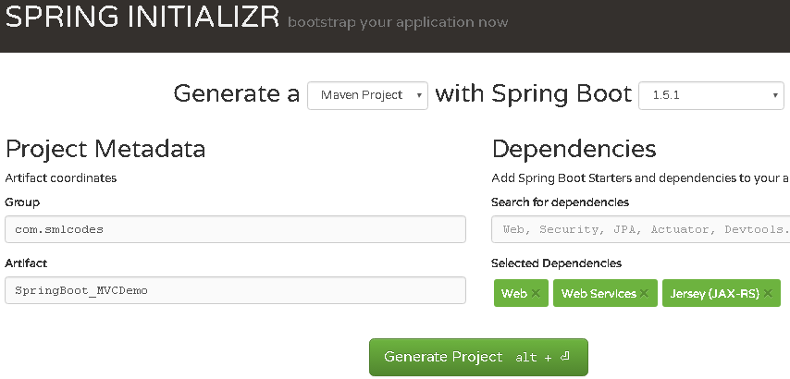
Extract, import to eclipse as Existing Maven project, & Run as→ maven install
If we see the Folder Structre
- all index, welcome files must be placed unter →resources\static\
- all the result pages must be placed under→resources\templates\
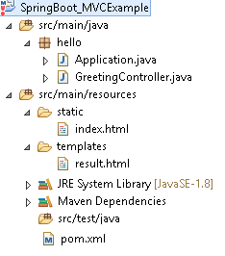

1.Choose the SpringBoot Stater Dependencies and place in pom.xml & build the project.
<?xml version="1.0" encoding="UTF-8"?>
<project xmlns="http://maven.apache.org/POM/4.0.0" xmlns:xsi="http://www.w3.org/2001/XMLSchema-instance"
xsi:schemaLocation="http://maven.apache.org/POM/4.0.0 http://maven.apache.org/xsd/maven-4.0.0.xsd">
<modelVersion>4.0.0</modelVersion>

<groupId>SpringBoot_MVCExample</groupId>
<artifactId>gs-serving-web-content</artifactId>
<version>SpringBoot_MVCExample</version>

<parent>
<groupId>org.springframework.boot</groupId>
<artifactId>spring-boot-starter-parent</artifactId>
<version>1.5.1.RELEASE</version>
</parent>

<dependencies>
<dependency>
<groupId>org.springframework.boot</groupId>
<artifactId>spring-boot-starter-test</artifactId>
<scope>test</scope>
</dependency>
</dependencies>

<properties>
<java.version>1.8</java.version>
</properties>

<build>
<plugins>
<plugin>
<groupId>org.springframework.boot</groupId>
<artifactId>spring-boot-maven-plugin</artifactId>
</plugin>
</plugins>
</build>

</project>

2.Create index.html to provide user input
///SpringBoot_MVCExample/src/main/resources/static/index.html
<h2>Spring Boot MVC Example</h2>
<form method="get" action="/hello">
<h3>Enter Your name : <input type="text" name="name"></h3>
<button type="submit">Enter</button>
</form>

3.Create Controller to hadle request given by user (/hello)
package hello;
import org.springframework.stereotype.Controller;
import org.springframework.ui.Model;
import org.springframework.web.bind.annotation.RequestMapping;
import org.springframework.web.bind.annotation.RequestParam;

@Controller
public class GreetingController {

@RequestMapping("/hello")
public String greeting(@RequestParam(value="name", required=false, defaultValue="World") String name, Model model) {
model.addAttribute("name", name);
return "result";
}
}
Here Model is a interface which conatins some usefull method to return result data to result page

4.Create result.html template to display the Results given by Controller
<!DOCTYPE HTML>
<html xmlns:th="http://www.thymeleaf.org">
<body>
<h1><p th:text="'Hello, ' + ${name} + '!'" /></h1>
</body>
</html>

5.Create Application.java to Start & Run Spring Boot Application
package hello;
import org.springframework.boot.SpringApplication;
import org.springframework.boot.autoconfigure.SpringBootApplication;

@SpringBootApplication
public class Application {
public static void main(String[] args) {
SpringApplication.run(Application.class, args);
}
}

6.Strat the Application by Run as→ Java Application (Application.java)
. ____ _ __ _ _
/\\ / ___'_ __ _ _(_)_ __ __ _ \ \ \ \
( ( )\___ | '_ | '_| | '_ \/ _` | \ \ \ \
\\/ ___)| |_)| | | | | || (_| | ) ) ) )
' |____| .__|_| |_|_| |_\__, | / / / /
=========|_|==============|___/=/_/_/_/
:: Spring Boot :: (v1.5.1.RELEASE)
2017-02-02TomcatEmbeddedServletContainer : Tomcat started on port(s): 8080
7.Open browser, access localhost:8080 the Output should be as below
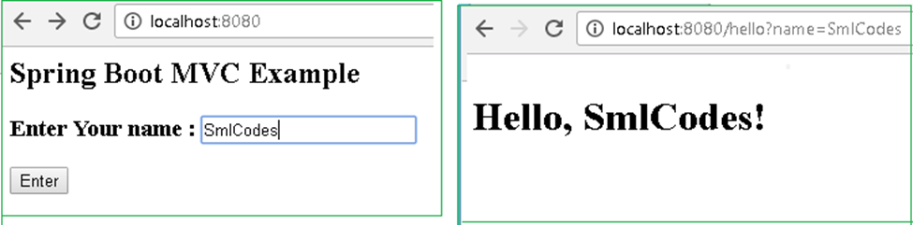

Explanation
1.On Running Applicatio.java, Spring Boot Engine Starts and reads the all files in the projects and autowires the data and auto configures the Controller details
2.on submitting the form, Spring Boot Searchers for controller classes which are annotated with @Controller
3.compairs (“/hello”) path with controller @RequestMapping("/hello"), if matches execute the business logic method and it returns the resultpage name(“result”)
4.SpringBoot Engine Searches the appropriate resultpage template having “result” as page name & displays the result.html page to the user

1.Model Interface
Model interface designed for adding attributes to the model. Allows for accessing the overall model as a java.util.Map.
Method Summary
Model | addAllAttributes(Collection<?> attributeValues)  Copy all attributes in the supplied Collection into this Map,
Model | addAllAttributes(Map<String,?> attributes)  Copy all attributes in the supplied Map into this Map.
Model | addAttribute(Object attributeValue)  Add the supplied attribute to this Map using a generated name.
Model | addAttribute(String attributeName, Object attributeValue)  Add the supplied attribute under the supplied name.
Map<String,Object> | asMap() - Return the current set of model attributes as a Map.
boolean | containsAttribute(String attributeName)  Does this model contain an attribute of the given name?
Model | mergeAttributes(Map<String,?> attributes)

2.Static Content
By default, Spring Boot will serve static content from a directory called /static (or /public or /resources or /META-INF/resources)
You can also customize the static resource locations using spring.resources.static-locations (replacing the default values with a list of directory locations).
If you do this the default welcome page detection will switch to your custom locations, so if there is an index.html in any of your locations on startup, it will be the home page of the application.

Spring Boot –RESTful Web Service Example
To work with webservices in SpringBoot we have to use two annotations
- @RestController: tells Spring Boot to consider this class as REST controller
- @RequestMapping: used to register paths inside it to respond to the HTTP requests.
The @RestController is a stereotype annotation. It adds @Controller and @ResponseBody annotations to the class.
@RestController = @Controller + @ResponseBody
Note - The @RestController and @RequestMapping annotations are Spring MVC annotations. They are not specific to Spring Boot.

app.controller.SpringBootRestController.java
package app.controller;

import org.springframework.web.bind.annotation.RestController;
import org.springframework.web.bind.annotation.RequestMapping;

@RestController
public class SpringBootRestController {

@RequestMapping("/")
public String welcome() {
return "Spring Boot Home Page";
}

@RequestMapping("/hello")
public String myData() {
return "Smalcodes : Hello Spring Boot";
}
}

app.SpringBootApp.java
package app;

import org.springframework.boot.SpringApplication;
import org.springframework.boot.autoconfigure.SpringBootApplication;

@SpringBootApplication
public class SpringBootApp {
public static void main(String[] args) {

SpringApplication.run(SpringBootApp.class, args);

}
}
Create pom.xml same as fisrt example.
Test the Application
Right click on project > Run as >Java Application >select SpringBootApp
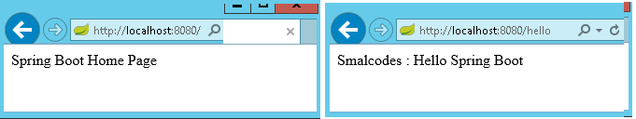
- In above Spring Boot main application class in app package and controller class in app.controller. While starting our application, SpringBootApp class will scan all the components under that package. As we have created our controller class in app.controller which is inside app package, our controller was registered by spring boot.

- If you create the controller class outside of the main package, lets say com.smlcodes.controller, If you run the application it gives 404 error.To resolve this, we have to add @ComponentScan annotation in our Spring Boot main class, as below

@SpringBootApplication
@ComponentScan(basePackages="smlcodes.controller")
public class SpringBootApp {
public static void main(String[] args) {
SpringApplication.run(SpringBootApp.class, args);
}
}

5. Spring Boot –Database

Spring Boot –JDBC Example
Spring Boot provides starter and libraries for connecting to our application with JDBC. Spring JDBC dependencies can be resolved by using either spring-boot-starter-jdbc or spring-boot-starter-data-jpa spring boot starters.

1.Create project Structure
To create project go to https://start.spring.io/ and add JDBC,MySQL,JPA dependencies to the Project. 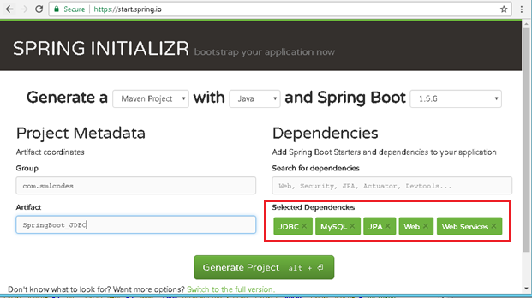

Configure DataSource (application. properties)
DataSource and Connection Pool are configured in application.properties file using prefix spring.datasource. Spring boot uses javax.sql.DataSource interface to configure DataSource
spring.datasource.url=jdbc:mysql://localhost:3306/springdb?useSSL=false
spring.datasource.username=root
spring.datasource.password=root
spring.datasource.driver-class-name=com.mysql.jdbc.Driver

Model Class(model.Student.java)
Find the MySQL table used in our example.
CREATE TABLE `student` (
`sno` INT(11) NOT NULL,
`name` VARCHAR(50) NULL DEFAULT NULL,
`address` VARCHAR(50) NULL DEFAULT NULL,
PRIMARY KEY (`sno`)
)
COLLATE='latin1_swedish_ci'
ENGINE=InnoDB
;

Create Student class with table properties
package app.model;

public class Student {
private int sno;
private String name;
private String address;

public Student() {
super();
}

public Student(int sno, String name, String address) {
super();
this.sno = sno;
this.name = name;
this.address = address;
}

public int getSno() {
return sno;
}

public void setSno(int sno) {
this.sno = sno;
}

public String getName() {
return name;
}

public void setName(String name) {
this.name = name;
}

public String getAddress() {
return address;
}

public void setAddress(String address) {
this.address = address;
}

}

DAO Class with JdbcTemplate (StudentDAO.java)
- JdbcTemplate is the central class to handle JDBC. It executes SQL queries and fetches their results. To use JdbcTemplate.
- JdbcTemplate dependency injection using @Autowired with constructor.
package app.dao;

import java.util.List;
import org.springframework.beans.factory.annotation.Autowired;
import org.springframework.jdbc.core.JdbcTemplate;
import org.springframework.stereotype.Repository;
import app.model.Student;

@Repository
public class StudentDAO {

@Autowired
private JdbcTemplate template;

public List<Student> findAll() {

List<Student> result = template.query("SELECT sno,name, address FROM Student", new StudentRowMapper());
return result;
}

public void addStudent(int sno, String name, String address) {
template.update("INSERT INTO Student(sno,name, address) VALUES (?,?,?)", sno, name, address);
}

}

RowMapper Class
Spring JDBC provides RowMapper interface that is used to map row with a java object. We need to create our own class implementing RowMapper interface to map row with java object. Find the sample code to implement RowMapperinterface.
package app.dao;
import java.sql.ResultSet;
import java.sql.SQLException;
import org.springframework.jdbc.core.RowMapper;
import app.model.Student;

public class StudentRowMapper implements RowMapper<Student> {
@Override
public Student mapRow(ResultSet rs, int rowno) throws SQLException {
// TODO Auto-generated method stub
Student s = new Student();
s.setSno(rs.getInt("sno"));
s.setName(rs.getString("name"));
s.setAddress(rs.getString("address"));
return s;
}
}

SpringBootJdbcController.java
package app.controller;
import org.springframework.web.bind.annotation.RestController;
import app.dao.StudentDAO;
import app.model.Student;
import java.util.Iterator;
import java.util.List;
import org.springframework.beans.factory.annotation.Autowired;
import org.springframework.web.bind.annotation.RequestMapping;
import org.springframework.web.bind.annotation.RequestParam;

@RestController
public class SpringBootJDBCController {

@Autowired
private StudentDAO dao;

@RequestMapping("/jdbc")
public String welcome() {
return "Spring Boot Home Page";
}

@RequestMapping("/insert")
public String insert(@RequestParam("sno") int sno, @RequestParam("name") String name,
@RequestParam("address") String adr) {
System.out.println(" ************** Inside Method ************");

dao.addStudent(sno, name, adr);
return "Data Inserted";
}

@RequestMapping("/select")
public String select() {
String result="";
List<Student> list = dao.findAll();
Iterator<Student> itr = list.iterator();
while (itr.hasNext()) {
Student s = (Student) itr.next();
result = result+ s.getSno()+", ";
result = result+ s.getName()+", ";
result = result+ s.getAddress()+" <br>";
}
System.out.println("Result : "+result);
return result;
}
}

SpringBootApp.java
package app;
import org.springframework.boot.SpringApplication;
import org.springframework.boot.autoconfigure.SpringBootApplication;

@SpringBootApplication
public class SpringBootApp {
public static void main(String[] args) {
SpringApplication.run(SpringBootApp.class, args);
}
}
Static/index.jsp
<a href="/select">SELECT</a><br />

<h1>Insert Form</h1>
<form action="/insert">
Sno: <input name="sno" type="text" /> <br>
Name: <input name="name" type="text" /> <br>
Address: <input name="address" type="text" /> <br>
<input type="submit" value="INSERT" /> <br>
</form>
</body>
</html>

Rightclikc on Project> Runas> Java Application 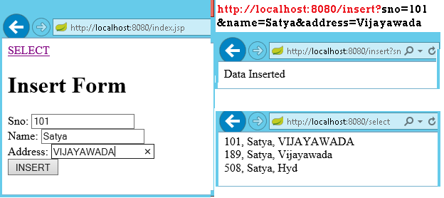

We can discard RowMapper class if we write following code in StudentDAO class it self.
@Repository
public class StudentDAO {

@Autowired
private JdbcTemplate template;

public List<Student> findAll() {

List<Student> result = template.query("SELECT sno,name, address FROM Student",
(rs, rowNum) -> new Student(rs.getInt("sno"),
rs.getString("name"), rs.getString("address")));
return result;

}

public void addStudent(int sno, String name, String address) {
template.update("INSERT INTO Student(sno,name, address) VALUES (?,?,?)",
sno, name, address);
}
}

Spring Boot –JPA Example
Spring Boot provides spring-boot-starter-data-jpa starter to connect Spring application with relational database efficiently. You can use it into project POM (Project Object Model) file.

JPA Annotations
By default, each field is mapped to a column with the name of the field. You can change the default name via @Column (name="newColumnName").
The following annotations can be used.
@Entity | Marks java class to a Table name
@Table(name="tabname") | Provides table name, when table name & class names are different .
@Id | Identifies the unique ID of the database entry
@GeneratedValue | Together with an ID this annotation defines that value is generated automatically.
@Transient | Field will not be saved in database
The central interface in Spring Data repository abstraction is Repository (probably not that much of a surprise). It takes the domain class to manage as well as the id type of the domain class as type arguments.

CrudRepository
The CrudRepository provides sophisticated CRUD functionality for the entity class that is being managed
public interface CrudRepository<T, ID extends Serializable> extends Repository<T, ID> {

<S extends T> S save(S entity);
T findOne(ID primaryKey);
Iterable<T> findAll();
Long count();
void delete(T entity);
boolean exists(ID primaryKey);
// … more functionality omitted.
}

PagingAndSortingRepository
On top of the CrudRepository there is a PagingAndSortingRepository abstraction that adds additional methods to ease paginated access to entities:
public interface PagingAndSortingRepository<T, ID extends Serializable>
extends CrudRepository<T, ID> {
Iterable<T> findAll(Sort sort);
Page<T> findAll(Pageable pageable);
}
1.Entity class : Student.java
1. create an entity class that contains the information of a single Student entry
package app.entity;

import javax.persistence.Column;
import javax.persistence.Entity;
import javax.persistence.GeneratedValue;
import javax.persistence.GenerationType;
import javax.persistence.Id;
import javax.persistence.Table;

@Entity
@Table(name = "student")
public class Student {

@Id
@GeneratedValue(strategy = GenerationType.AUTO)
private int sno;

@Column(name = "name")
private String name;

@Column(name = "address")
private String address;

public Student() {
super();
}

public Student(int sno, String name, String address) {
super();
this.sno = sno;
this.name = name;
this.address = address;
}

//Setters & getters
}

StudentRepository.java
We can create the repository that provides CRUD operations for Student objects by using one of the following methods:
- Create an interface that extends the CrudRepository interface.
- Create an interface that extends the Repository interface and add the required methods to the created interface.
package app.repository;
import org.springframework.data.repository.CrudRepository;
import app.entity.Student;

public interface StudentRepository extends CrudRepository<Student, String>{

}

StudentService.java
package app.service;

@Service
public class StudentService {

@Autowired
private StudentRepository repository;

public List<Student> getAllStudents() {
List<Student> studentRecords = new ArrayList<>();
repository.findAll().forEach(studentRecords::add);
return studentRecords;
}

public Student getStudent(String id) {
return repository.findOne(id);
}

public void addStudent(Student studentRecord) {
repository.save(studentRecord);
}

public void delete(String id) {
repository.delete(id);
}
}

StudentController.java
package app.controller;

@RestController
public class StudentController {
@Autowired
private StudentService studentService;

@RequestMapping("/")
public List<Student> getAllStudent() {
return studentService.getAllStudents();
}

@RequestMapping(value = "/add", method = RequestMethod.POST)
public void addStudent(@RequestBody Student student) {
studentService.addStudent(student);
}

@RequestMapping(value = "/get/{id}", method = RequestMethod.GET)
public Student getStudent(@PathVariable String id) {
return studentService.getStudent(id);
}
}

SpringBootApp.java
@SpringBootApplication
public class SpringBootApp {
public static void main(String[] args) {
SpringApplication.run(SpringBootApp.class, args);
}
}

http://localhost:8080/ -get All Srudents
[
{
"sno": 189,
"name": "Satya",
"address": "Vijayawada"
},
{
"sno": 508,
"name": "Satya",
"address": "Hyd"
}
]
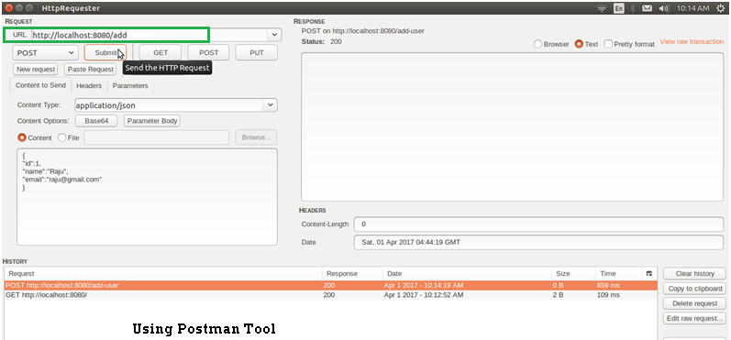

JpaRepository
JpaRepository provides some JPA related method such as flushing the persistence context and delete record in a batch. JpaRepository extends PagingAndSortingRepository which in turn extends CrudRepository.
Their main functions are:
- CrudRepository mainly provides CRUD functions.
- PagingAndSortingRepository provide methods to do pagination and sorting records.
- JpaRepository provides some JPA related method such as flushing the persistence context and delete record in a batch.
Because of the inheritance mentioned above, JpaRepository will have all the functions of CrudRepository and PagingAndSortingRepository.

Custom Queries
Spring Data JPA provides three different approaches for creating custom queries with query methods. Each of these approaches is described in following.

Using Method Name
- Spring Data JPA has a built in query creation mechanism which can be used for parsing queries straight from the method name of a query method.
- the method names of your repository interface are created by combining the property names of an entity object and the supported keywords.
public interface PersonRepository extends Repository<User, Long> {

List<Person> findByEmailAddressAndLastname(EmailAddress emailAddress, String lastname);

// Enables the distinct flag for the query
List<Person> findDistinctPeopleByLastnameOrFirstname(String lastname, String firstname);
List<Person> findPeopleDistinctByLastnameOrFirstname(String lastname, String firstname);

// Enabling ignoring case for an individual property
List<Person> findByLastnameIgnoreCase(String lastname);

// Enabling ignoring case for all suitable properties
List<Person> findByLastnameAndFirstnameAllIgnoreCase(String lastname, String firstname);

// Enabling static ORDER BY for a query
List<Person> findByLastnameOrderByFirstnameAsc(String lastname);
List<Person> findByLastnameOrderByFirstnameDesc(String lastname);
}

JPA Named Queries
Spring Data JPA provides also support for the JPA Named Queries. You have got following alternatives for declaring the named queries:
- You can use either named-query XML element or @NamedQuery annotation to create named queries with the JPA query language.
- You can use either named-native-query XML element or @NamedNative query annotation to create queries with SQL if you are ready to tie your application with a specific database platform.
The only thing you have to do to use the created named queries is to name the query method of your repository interface to match with the name of your named query. See below Example code
@Entity
@NamedQuery(name = "Person.findByName", query = "SELECT p FROM Person p WHERE LOWER(p.lastName) = LOWER(?1)")
@Table(name = "persons")
public class Person {

@Id
@GeneratedValue(strategy = GenerationType.AUTO)
private Long id;

@Column(name = "creation_time", nullable = false)
private Date creationTime;

@Column(name = "first_name", nullable = false)
private String firstName;
}

The relevant part of my PersonRepository interface looks following
public interface PersonRepository extends JpaRepository<Person, Long> {
//A list of persons whose last name is an exact match with the given last name.
public List<Person> findByName(String lastName);
}

@Query Annotation
- The @Query annotation can be used to create queries by using the JPA query language and to bind these queries directly to the methods of your repository interface.
- When the query method is called, Spring Data JPA will execute the query specified by the @Query annotation
- If there is a collision between the @Query annotation and the named queries, the query specified by using @Query annotation will be executed
public interface ProductRepository
extends CrudRepository<Product, Long> {
@Query("FROM Product")
List<Product> findAllProducts();
}

You may use positional parameters instead of named parameters in queries. Positional parameters are prefixed with a question mark (?) followed the numeric position of the parameter in the query. The Query.setParameter(integer position, Object value) method is used to set the parameter values.
public List findWithName(String name) {
return em.createQuery(
“SELECT c FROM Customer c WHERE c.name LIKE ?1”)
.setParameter(1, name)
.getResultList();
}

Automatic Query Generation
The <jpa:repositories/> has an option query-lookup-strategy which defaults to “create-if-not-found” which will generate queries for us.The default is “create-if-not-found“. Other options are “create” or “use-declared-query“.
<jpa:repositories base-package="com.gordondickens.myapp.repository"
query-lookup-strategy="create-if-not-found"/>

To create a find method that effectively does @Query("FROM Product p where p.productId =:productId")
public interface ProductRepository extends CrudRepository<Product, Long> {
...

@Query
Product findByProductId(String productId);

...

Example
Student.java
package app.entity;

@Entity
@Table(name = "student")
public class Student {

@Id
@GeneratedValue(strategy = GenerationType.AUTO)
private int sno;

@Column(name = "name")
private String name;

@Column(name = "address")
private String address;

@Override
public String toString() {
String str = "Student[" + "Sno: " + getSno() + ", Name:" + getName() + ", " + "Address : " + getAddress() + "]";
return str;
}
//Setters & getters
}

StudentRepository.java
public interface StudentRepository extends CrudRepository<Student, Long> {

List<Student> findBySno(int sno);

List<Student> findByName(String name);

// custom query example and return a stream
@Query("select c from Student c where c.address = :address")
Stream<Student> findByAddress(@Param("address") String address);
}

Application.java
package app;

@SpringBootApplication
public class Application implements CommandLineRunner {

@Autowired
DataSource dataSource;

@Autowired
StudentRepository repository;

public static void main(String[] args) throws Exception {
SpringApplication.run(Application.class, args);
}

@Transactional(readOnly = true)
@Override
public void run(String... args) throws Exception {

System.out.println("DATASOURCE = " + dataSource);

System.out.println("\n1.findAll()...");
for (Student student : repository.findAll()) {
System.out.println(student);
}

System.out.println("\n2.findByName(String name)...");
for (Student student : repository.findByName("Satya")) {
System.out.println(student);
}

System.out.println("\n3.findByAddress(@Param(\"name\"))...");
try (Stream<Student> s =repository.findByAddress("Vijayawada")) {
s.forEach(x -> System.out.println(x));
System.out.println("Done!");
exit(0);
}
}
}
1.findAll()...
Student[Sno: 0, Name:null, Address : null]
Student[Sno: 101, Name:Satya, Address : VIJAYAWADA]
Student[Sno: 102, Name:Satya, Address : Vijayawada]
Student[Sno: 147, Name:kumar, Address : Hyderabad]
Student[Sno: 189, Name:Satya, Address : Vijayawada]
Student[Sno: 508, Name:Satya, Address : Hyd]

2.findByName(String name)...
Student[Sno: 101, Name:Satya, Address : VIJAYAWADA]
Student[Sno: 102, Name:Satya, Address : Vijayawada]
Student[Sno: 189, Name:Satya, Address : Vijayawada]
Student[Sno: 508, Name:Satya, Address : Hyd]

4.findByAddress(@Param("name") String name)...
Student[Sno: 101, Name:Satya, Address : VIJAYAWADA]
Student[Sno: 102, Name:Satya, Address : Vijayawada]
Student[Sno: 189, Name:Satya, Address : Vijayawada]

Spring Boot –MongoDB REST Example
Configuration file application.properties
# Create new database : ‘smlcodes’
spring.data.mongodb.database=smlcodes
spring.data.mongodb.host=localhost
spring.data.mongodb.port=27017

we need to model our documents. Let’s call ours ‘Booking’ and give it a make, model, and description. Here is our Java class to accomplish this
package smlcodes.repository;
import org.springframework.data.annotation.Id;
import org.springframework.data.mongodb.core.mapping.Document;

@Document
public class Student{

@Id
String sno;
String name;
String address;
public String getSno() {
return sno;
}
public void setSno(String sno) {
this.sno = sno;
}
public String getName() {
return name;
}
public void setName(String name) {
this.name = name;
}
public String getAddress() {
return address;
}
public void setAddress(String address) {
this.address = address;
}
}
- @Id- id provided by Mongo for a document.
- @Document- provides a collection name.

BookingRepository.java
The MongoRepository provides basic CRUD operation methods and also an API to find all documents in the collection.
@Transactional
public interface StudentRepository extends MongoRepository<Student, String> {
public Student findBySno(int sno);
}

BookingController.java
package smlcodes.controller;

@RestController
@RequestMapping("/student")
public class StudentController {

@Autowired
StudentRepository studentRepository;

@RequestMapping("/create")
public Map<String, Object> create(Student student) {
student = studentRepository.save(student);
Map<String, Object> dataMap = new HashMap<String, Object>();
dataMap.put("message", "Student created successfully");
dataMap.put("status", "1");
dataMap.put("student", student);
return dataMap;
}

@RequestMapping("/read")
public Map<String, Object> read(@RequestParam int sno) {
Student student = studentRepository.findBySno(sno);
Map<String, Object> dataMap = new HashMap<String, Object>();
dataMap.put("message", "Student found successfully");
dataMap.put("status", "1");
dataMap.put("student", student);
return dataMap;
}

@RequestMapping("/readall")
public Map<String, Object> readAll() {
List<Student> students = studentRepository.findAll();
Map<String, Object> dataMap = new HashMap<String, Object>();
dataMap.put("message", "Student found successfully");
dataMap.put("totalStudent", students.size());
dataMap.put("status", "1");
dataMap.put("students", students);
return dataMap;
}
}

SpringBootMongoDbApplication.java
@SpringBootApplication
public class SpringBootMongoDbApplication {
public static void main(String[] args) {
SpringApplication.run(SpringBootMongoDbApplication.class, args);
}
}

Test
http://localhost:8080/student/create?sno=101&name=Satya&address=HYDERABAD 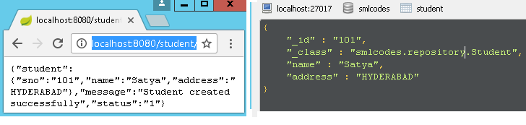

References
- http://sivalabs.in/2016/03/springboot-working-with-jdbctemplate/
- https://www.javatpoint.com/spring-boot-jpa
- https://www.petrikainulainen.net/programming/spring-framework/spring-data-jpa-tutorial-part-two-crud/
- https://www.dineshonjava.com/spring-boot-and-mongodb-in-rest-application/
- https://spring.io/guides/gs/spring-boot/#scratch
- http://docs.spring.io/autorepo/docs/spring-boot/current/reference/html/(best)
- http://www.dineshonjava.com/2016/06/introduction-to-spring-boot-a-spring-boot-complete-guide.html#.WI7wB1N965t
- http://websystique.com/spring-boot-tutorial/
- https://www.mkyong.com/tag/spring-boot/
- (Best)Helloworld : http://www.shristitechlabs.com/introduction-to-spring-boot/
- https://www.mkyong.com/spring-boot/spring-boot-spring-data-mongodb-example/
- https://tests4geeks.com/spring-data-boot-mongodb-example/
- https://avaldes.com/building-a-realtime-angularjs-dashboard-using-spring-rest-and-mongodb-part-1/
- Final:https://www.callicoder.com/spring-boot-mongodb-angular-js-rest-api-tutorial/
